Next Greater Element - 2
Problem Statement: Given a circular integer array arr, return the next greater element for every element in arr.
The next greater element for an element x is the first element greater than x that we come across while traversing the array in a clockwise manner.
If it doesn't exist, return -1 for that element element.
Example 1:
Input: arr = [3, 10, 4, 2, 1, 2, 6, 1, 7, 2, 9]
Output: [10, -1, 6, 6, 2, 6, 7, 7, 9, 9, 10]
Explanation: For the first element in arr i.e, 3, the greater element which comes next to it while traversing and is closest to it is 10. Hence,10 is present on index 0 in the resultant array. Now for the second element i.e, 10, there is no greater number and hence -1 is it’s next greater element (NGE). Similarly, we got the NGEs for all other elements present in arr.
Algorithm
- Initialize an answer array with default values of -1
- Initialize an empty stack to keep track of elements
- Traverse from 2n - 1 down to 0 using modulus to simulate circular indexing
- While stack is not empty and top of stack is less than or equal to current element, pop from stack
- If index is in the original array range, assign top of stack to answer if stack is not empty, else keep -1
- Push the current element onto the stack
- After traversal ends, return the answer array
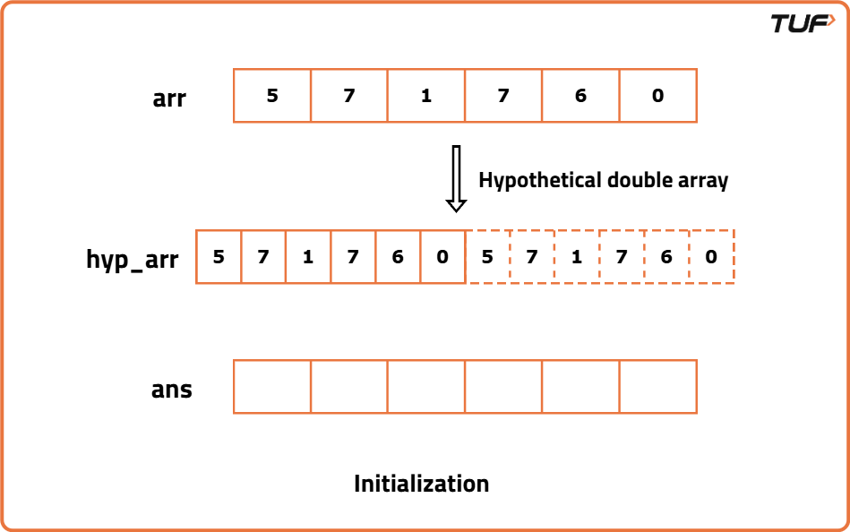
class Solution {

// Function to find the next greater element for each element in the array
public int[] nextGreaterElements(int[] arr) {
int n = arr.length;

// To store the next greater elements
int[] ans = new int[n];

// Stack to help find next greater elements in reverse traversal
Stack<Integer> st = new Stack<>();

// Traverse the array twice in reverse to simulate circular array
for (int i = 2 * n - 1; i >= 0; i--) {
int ind = i % n;
int currEle = arr[ind];

// Pop all elements from stack that are less than or equal to current
while (!st.isEmpty() && st.peek() <= currEle) {
st.pop();
}

// Only fill result in the first pass (i < n)
if (i < n) {
if (st.isEmpty()) {
ans[ind] = -1;
} else {
ans[ind] = st.peek();
}
}

// Push current element to stack
st.push(currEle);
}

return ans;
}
}

